**PROJECT DESIGN PHASE -2**

**TECHNOLOGY ARCHITECTURE**

|  |  |
| --- | --- |
| DATE | 15 OCTOBER 2022 |
| TEAM ID | PNT2022TMID36938 |
| PROJECT | SMART FASHION RECOMMENDER APPLICATION |
| MAXIMUM MARK | 4 Marks |

**TECHNOLOGY ARCHITECTURE:**

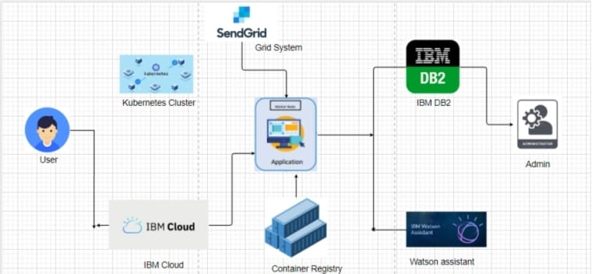

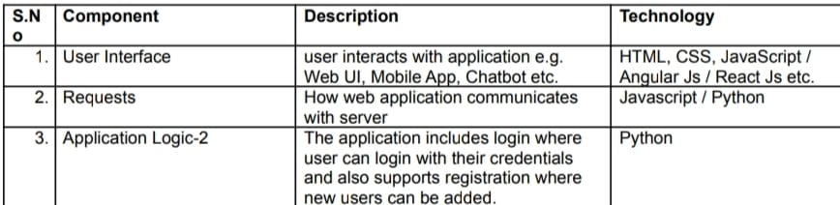

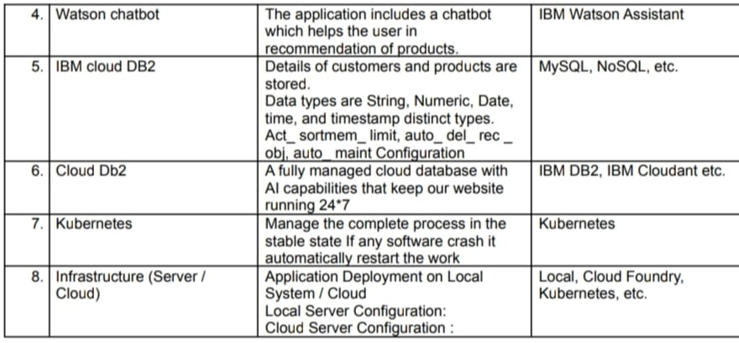

**TABLE 2- APPLICATION CHARACTERISTICS**

